|  |  |
| --- | --- |
|  | EUROPEAN COMMISSION  DIRECTORATE-GENERAL FOR AGRICULTURE AND RURAL DEVELOPMENT  Directorate C. CAP Strategic Plans I |

Brussels,

XML TECHNICAL SPECIFICATION

Create XML file for APR version 8.2

Subject: XML Technical specification for Annual Performance Report Background

The purpose of this document is to present the construction of the XML files that were uploaded by Member States (MS) for the submission of the annual performance report (APR) to the European Commission (EC) through SFC2021. Also, there will be a reference to different tools that will allow to create XML files that will pass the structure format and consistency checks.

Please be aware that XML file cannot be created using the EXCEL mapping the XSD structure into different sheets. The XML structure is complex, with different levels of data representation and EXCEL cannot handle this structure.

I recommend following steps in creating the XML:

1. Each section can be formatted into EXCEL, using as headers the attributes from XML file for specific sections separately.
2. Save data into CSV format

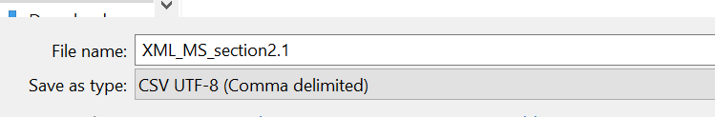

1. Open saved CSV into XML Notepad tool and format it accordingly. Please select “semicolon” as delimiter and check that first row information are headings

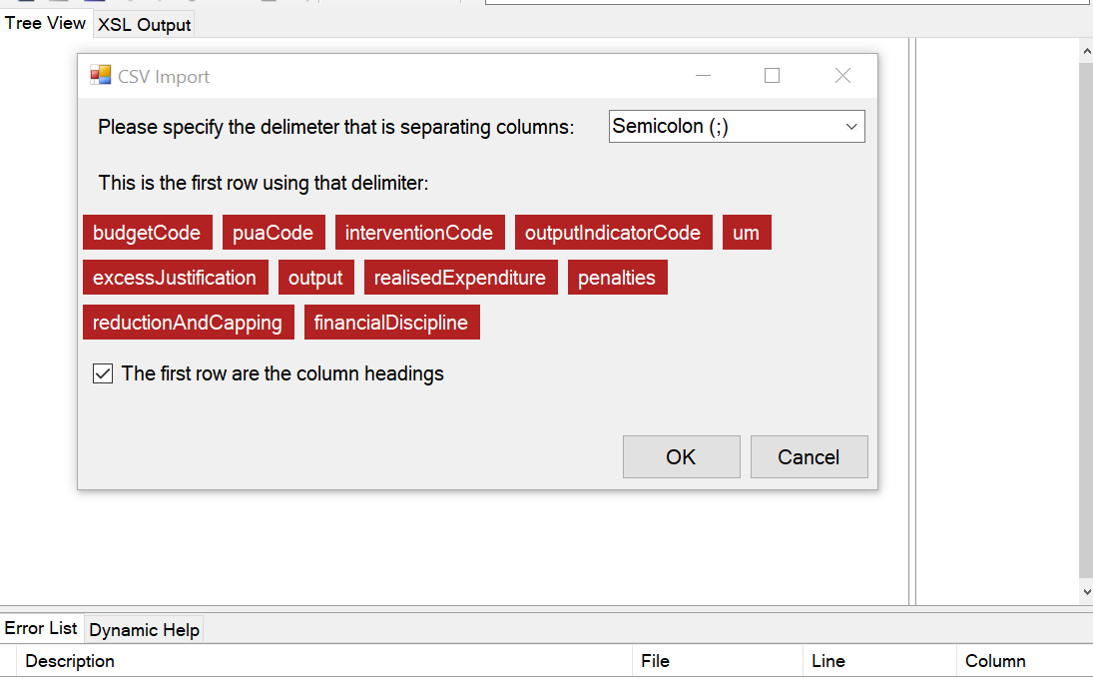

1. Adjust the XML created file with section information, headers and other requested attributes

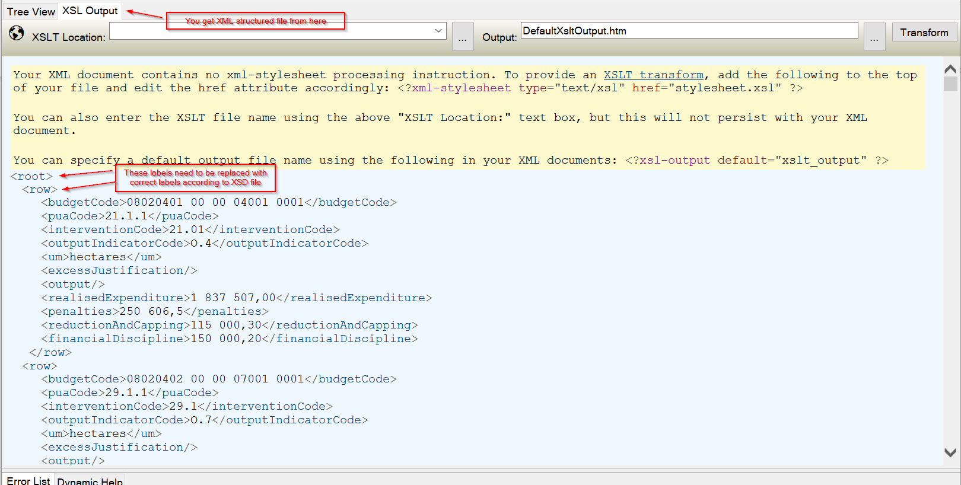

Please ensure that XML file is saved as UTF-8 format otherwise you may get troubles during upload into system. If what to be sure about format, please open the file with NOTEPAD++ and check in the ENCODING menu.

## Annual performance report: XML file content

Every file that needs to be uploaded, XML file containing all necessary data or only specific section information, will have in the beginning of the file the following header information:

Header (mandatory):

* XML file setup information
* Financial Year (based on the period of submission)
* CCI (reference of the CAP Plan)
* Currency (EURO expected)

*<?xml version="1.0" encoding="UTF-8" ?>*

*<apr xmlns="eu.europa.ec.agri.apr.v3_0">\*\**

*<header>*

*<CCI>2023BG06AFSP001</CCI>*

*<financialYear>2024</financialYear>*

*<currency>EUR</currency>*

*</header>*

**Namespace version for XML has been modified from version 2.0 to version 3.0 starting 2025

Please be aware that CCI is unique for each MS, and this will be the first consistency check that will be done when uploading XML files. Also, please be aware that the CSP version that will be used for checking and validate data uploaded in APR will be the last “Adopted by EC” version before closing of financial period.

Body of XML file can contain definitions for all sections from Quantitative part or only single section (e.g. 2.2.1 Direct Payments, 2.3.3 Other Aggregated Values…). Important to remember is that if multiple file option will be used, the above information need to be provided in each single file.

Standard Unit of Measurement should be used in all sections, except the case where you have CUSTOM UM or in case of aggregated values where for Category=Financial Instruments you need to declare ‘Final recipient’ as UM. The standard UM are presented in the *UnitMeasurement_standard.xlsx* document found at the end. For all standard UM that need to be represented in XML please use the codes of Um. In case you have custom UM please write the description of this UM in the XML file

Body of the Annual Performance XML file:

**Section 2.1 - Achieved values of result indicators and comments**: *<resultIndicators><resultIndicator>*

|  |  |
| --- | --- |
| **Item *<XMLtag>*** | **Information to be placed in XML** |
| Result indicator *<result IndicatorCode>* | R.1 to R.44 values as text |
| Sector* *<sector>* | Name of Sector as text information (EN)(e.g. FV, Other-MILK, Other-Cereals…) |
| Numerator** *<numeratorCategory>* | Text expected from a predefined code list – one of the categories defined for specific Result Indicators (EN) |
| Numerator value *<numeratorValue>* | Number 15 chars, 2 decimals, no thousand separators, with a positive (+) or negative (-) sign |
| Denominator value *<denominatorValue>* | Number 15 chars, 2 decimals, no thousand separators, with a positive (+) or negative (-) sign |
| Comment on deviation from milestone *<comment>* | Text max 2000 chars including spaces, in local language |

\**Sector valid only for R11*

*\*\* Numerator list can be found in XML_CATEGORY_GROUP_ResultsInd.xlsx document*

*<resultIndicators>*

*<resultIndicator>*

*<resultIndicatorCode>R.11</resultIndicatorCode>*

*<sector>Milk</sector>*

*<sectorOtherName>ZEMIAKY</sectorOtherName>\*\*\**

*<numeratorCategory></numeratorCategory>*

*<numeratorValue>100.33</numeratorValue>*

*<denominatorValue>10.00</denominatorValue>*

*<comment>here is the comment</comment>*

*</resultIndicator>*

*</resultIndicators>*

*** - to be used only in case SECTOR = OTHER-ANVI. SectorOtherName should be the name of sector as defined in CSP

**Section 2.2 - Realised outputs - unit amounts:  
*<realisedOutputs>***

Section 2.2.1 - Realised outputs - unit amounts - direct payments:  
*<realisedOutputDp>*

|  |  |
| --- | --- |
| **Item *<XMLtag>*** | **Information to be placed in XML** |
| Unit amount budget code *<budgetCode>* | First 21 digits of the EU budget code |
| Planned unit amount code *<puaCode>* | Unit amount code as defined by MS in the CAP SP – Text information |
| Planned unit amount group code* *<puaGroupCode>* | Grouped unit amount code as defined by MS in the CAP SP (when applicable) – Text information |
| Intervention *<interventionCode>* | Intervention code as defined by MS in the CAP SP-– Text information |
| Output indicator *<outputIndicatorCode>* | O.1 to O.37 - Text information as defined by MS in the CAP SP |
| Unit of measurement *<um>* | Code expected in case of Standard UM and name for custom UM |
| Realised output *<output>* | Number 15 chars, 4 decimals, no thousand separators, with a positive (+) or negative (-) sign(e.g 123/-888) |
| EU amount not paid following reduction and capping *<reductionAndCapping>* | Number 15 chars, 2 decimals, no thousand separators, with a positive (+) or negative (-) sign(e.g 123/-888) |
| EU amount not paid following financial discipline *<financialDiscipline>* | Number 15 chars, 2 decimals, no thousand separators, with a positive (+) or negative (-) sign(e.g 123/-888) |
| EU amount not paid following penalties *<penalties>* | Number 15 chars, 2 decimals, no thousand separators, with a positive (+) or negative (-) sign(e.g 123/-888) |
| Gross realised expenditure *<realisedExpenditure>* | Number 15 chars, 2 decimals, no thousand separators, with a positive (+) or negative (-) sign(e.g 123/-888) |
| Justification of excess *<excessJustification>\*\** | Text max 2000 chars including spaces, in local language |

\**Not expected in XML file for DP interventions*

*\*\*In case a special text is expected please use below format*

*<![CDATA[<MAX]]> in case you need to add in XML comment ‘<MAX’*

*<realisedOutputs>*

*<realisedOutputDp>*

*<identifier>*

*<budgetCode>080204010000040020001</budgetCode>*

*<puaCode>I.А.1-1</puaCode>*

*<interventionCode>I.А.1</interventionCode>*

*<outputIndicatorCode>O.4</outputIndicatorCode>*

*<um>ha</um>*

*</identifier>*

*<excessJustification>* *<![CDATA[<MAX]]></excessJustification>*

*<output>100.22</output>*

*<realisedExpenditure>234.66</realisedExpenditure>*

*<penalties>100.44</penalties>*

*<reductionAndCapping>111.65</reductionAndCapping>*

*<financialDiscipline>4.34</financialDiscipline>*

*</realisedOutputDp>*

*</realisedOutputs>*

Section 2.2.2 - Realised outputs - unit amounts - sectoral interventions:  
*<realisedOutputSectoral>*

|  |  |
| --- | --- |
| **Item *<XMLtag>*** | **Information to be placed in XML** |
| Unit amount budget code *<budgetCode>* | First 21 digits of the EU budget code |
| Planned unit amount code *<puaCode>* | Unit amount code as defined by MS in the CAP SP – Text information |
| Planned unit amount group code* *<puaGroupCode>* | Grouped unit amount code as defined by MS in the CAP SP (when applicable)- – Text information |
| Intervention *<interventionCode>* | Intervention code as defined by MS in the CAP SP-– Text information |
| Output indicator *<outputIndicatorCode>* | O.1 to O.37 - Text information as defined by MS in the CAP SP |
| Unit of measurement *<um>* | Code expected in case of Standard UM and name for custom UM |
| Realised output *<output>* | Number 15 chars, 4 decimals, no thousand separators, with a positive (+) or negative (-) sign(e.g 123/-888) |
| EU amount not paid following a limitation due to the proportion of the value of the marketed production *<limitationOnProportion>* | Number 15 chars, 2 decimals, no thousand separators, with a positive (+) or negative (-) sign(e.g 123/-888) |
| Advances in financial years N-1 and earlier (if relevant for related output in financial year N)  <*advancesInPreviousFinancialYear*> | Number 15 chars, 2 decimals, no thousand separators, with a positive (+) or negative (-) sign(e.g 123/-888) |
| EU amount not paid following penalties *<penalties>* | Number 15 chars, 2 decimals, no thousand separators, with a positive (+) or negative (-) sign(e.g 123/-888) |
| Advances in financial year N for which there is no relevant output in financial year N (minus amount)  <*advancesInFinancialYear*> | Number 15 chars, 2 decimals, no thousand separators, with a positive (+) or negative (-) sign(e.g 123/-888) |
| Gross realised expenditure *<realisedExpenditure>* | Number 15 chars, 2 decimals, no thousand separators, with a positive (+) or negative (-) sign |
| Justification of excess *<excessJustification>\*\** | Text max 2000 chars including spaces, in local language |
|  |  |

\**Expected only for sectoral interventions where Planned Unit Amount defined at sector level (e.g. FV, OTHER…). For API and WINE no puaGroupCode is needed. XML validation rule exist to check if for O.35 there is a PuaGroupCode defined in XML*

*\*\*In case a special text is expected please use below format*

*<![CDATA[<MAX]]> in case you need to add in XML comment ‘<MAX’*

*<realisedOutputs>*

*<realisedOutputSectoral>*

*<identifier>*

*<budgetCode>080204010000040020001</budgetCode>*

*<puaGroupCode>FV</puaGroupCode>*

*<puaCode>I.Е.6</puaCode>*

*<interventionCode> </interventionCode>*

*<outputIndicatorCode>O.37</outputIndicatorCode>*

*<um>op</um>*

*</identifier>*

*<excessJustification>No COMMENTS </excessJustification>*

*<output>100.22</output>*

*<realisedExpenditure>234.66</realisedExpenditure>*

*<penalties>100.44</penalties>*

*<limitationOnProportion>11234.34</limitationOnProportion>*

<*advancesInFinancialYear*></*advancesInFinancialYear*>

<*advancesInPreviousFinancialYear*></*advancesInPreviousFinancialYear*>

*</realisedOutputSectoral>*

*</realisedOutputs>*

*For case when OTHER-ANVI sector need to be declared please use following format:*

*<realisedOutputSectoral>*

*<identifier>*

*<budgetCode>080202062900350000001</budgetCode>*

*<puaGroupCode>ZEMIAKY</puaGroupCode>*

*<puaCode>67.1</puaCode>*

*<outputIndicatorCode>O.35</outputIndicatorCode>*

*<um>op</um>*

*</identifier>*

*…..*

Where ‘ZEMIAKY’ is the sector name in original language define under OTHER-ANVI

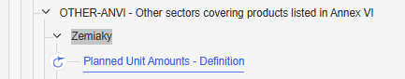

Section 2.2.3 - Realised outputs - unit amounts - rural development:  
*<realisedOutputRd>*

|  |  |
| --- | --- |
| **Item *<XMLtag>*** | **Information to be placed in XML** |
| Unit amount budget code *<budgetCode>* | First 21 digits of the EU budget code |
| Planned unit amount code *<puaCode>* | Unit amount code as defined by MS in the CAP SP – Text information |
| Planned unit amount group code* *<puaGroupCode>* | Grouped unit amount code as defined by MS in the CAP SP (when applicable)- – Text information |
| Intervention *<interventionCode>* | Intervention code as defined by MS in the CAP SP-– Text information |
| Output indicator *<outputIndicatorCode>* | O.1 to O.37 - Text information as defined by MS in the CAP SP |
| Unit of measurement *<um>* | Code expected in case of Standard UM and name for custom UM |
| Realised output excluding outputs generated exclusively by additional national financing *<output>* | Number 15 chars, 4 decimals, no thousand separators, with a positive (+) or negative (-) sign (e.g 123/-888) |
| Contribution rate applicable at Unit Amount Level<*contributionRate*> | Number 2 chars, 2 decimals, no thousand separators, with a positive (+)(e.g 123) |
| Public expenditure excluding additional national financing: Amount recovered within the current period *<recovered>* | Number 15 chars, 2 decimals, no thousand separators, with a positive (+) or negative (-) sign(e.g 123/-888) |
| Public expenditure excluding additional national financing: Amount recovered from a closed period  *<recoveredFromClosedPeriod>* | Number 15 chars, 2 decimals, no thousand separators, with a positive (+) or negative (-) sign(e.g 123/-888) |
| Public expenditure excluding additional national financing: Advances in financial years N-1 and earlier (if relevant for related output in financial year N)  <*advancesInPreviousFinancialYear*> | Number 15 chars, 2 decimals, no thousand separators, with a positive (+) or negative (-) sign(e.g 123/-888) |
| Public expenditure excluding additional national financing: Amount not paid following penalties *<penalties>* | Number 15 chars, 2 decimals, no thousand separators, with a positive (+) or negative (-) sign(e.g 123/-888) |
| Public expenditure excluding additional national financing: Advances in financial year N for which there is no relevant output in financial year N (minus amount)  <*advancesInFinancialYear*> | Number 15 chars, 2 decimals, no thousand separators, with a positive (+) or negative (-) sign(e.g 123/-888) |
| Public expenditure excluding additional national financing: Gross realised expenditure *<realisedExpenditure>* | Number 15 chars, 2 decimals, no thousand separators, with a positive (+) or negative (-) sign(e.g 123/-888) |
| Justification of excess *<excessJustification>\*\** | Text max 2000 chars including spaces, in local language |

\**Not expected in XML file for RD interventions*

*\*\*In case a special text is expected please use below format*

*<![CDATA[<MAX]]> in case you need to add in XML comment ‘<MAX’*

*<realisedOutputs>*

*<realisedOutputRd>*

*<identifier>*

*<budgetCode>080204010000040020001</budgetCode>*

*<puaCode>HP3</puaCode>*

*<interventionCode>II.Б.1.</interventionCode>*

*<outputIndicatorCode>O.12</outputIndicatorCode>*

*<um>actions</um>*

*</identifier>*

*<excessJustification>No COMMENTS </excessJustification>*

*<output>100.22</output>*

*<realisedExpenditure>234.66</realisedExpenditure>*

*<penalties>100.44</penalties>*

*<recovered>11234.34</ recovered >*

<*advancesInFinancialYear*></*advancesInFinancialYear*>

<*advancesInPreviousFinancialYear*></*advancesInPreviousFinancialYear*>

*<contributionRate>38.01</contributionRate>*

*</realisedOutputRd>*

*</realisedOutputs>*

Section 2.2.4 - Realised outputs – interventions - additional national financing – national financial assistance:  
*<additionalNationalFinancing>*

|  |  |
| --- | --- |
| **Item *<XMLtag>*** | **Information to be placed in XML** |
| Intervention budget code *<budgetCode>* | First 17 digits of the EU budget code |
| Intervention *<interventionCode>* | Intervention code as defined by MS in the CAP SP-– Text information |
| Output indicator *<outputIndicatorCode>* | O.1 to O.37 - Text information as defined by MS in the CAP SP |
| Unit of measurement *<um>* | Code expected in case of Standard UM and name for custom UM |
| Realised outputs exclusively generated by additional national financing (with double counting) *<output>* | Number 15 chars, 2 decimals, no thousand separators, with a positive (+) or negative (-) sign(e.g 123/-888) |
| Additional national financing (for rural development interventions) or national financial assistance (for F&V sectoral interventions) *<NationalFinancing>* | Number 15 chars, 2 decimals, no thousand separators, with a positive (+) or negative (-) sign(e.g 123/-888) |

*</realisedOutputs>*

*<additionalNationalFinancing>*

*<identifier>*

*<budgetCode>08030101000212001</budgetCode>*

*<interventionCode>II.Б.1.</interventionCode>*

*<outputIndicatorCode>O.12</outputIndicatorCode>*

*<um>ha</um>*

*</identifier>*

*<output>100</output>*

*<nationalFinancing>333</nationalFinancing>*

*</additionalNationalFinancing>*

*</realisedOutputs>*

For FV additional national financing please use below format into XML:

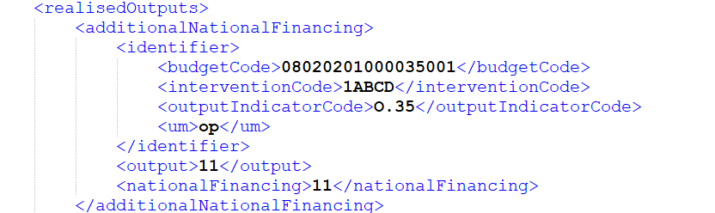

**Section 2.3 - Realised outputs - aggregated values:  
*<aggregatedValues>***

Section 2.3.1 - Realised outputs - aggregated values by intervention:  
*<aggregatedValuesByIntervention><aggregatedValue>*

|  |  |
| --- | --- |
| **Item *<XMLtag>*** | **Information to be placed in XML** |
| Intervention budget code *<budgetCode>* | First 17 digits of the EU budget code |
| Intervention *<interventionCode>* | Intervention code as defined by MS in the CAP SP-– Text information |
| Intervention label* *<interventionName>* | Automatically collected from CAP |
| Type of intervention *<typeOfInterventionCode>* | Type of Intervention code as commonly defined in CAP SP (e.g. BISS) – Text information |
| Output indicator *<outputIndicatorCode>* | O.1 to O.37, excluding O.35 - Text information as defined by MS in the CAP SP |
| Category** <*category*> | Text expected from a predefined code list – one of the categories defined for specific Output Indicators (EN) |
| Sector*** <*sector*> | Text information from a predefined code list (EN) |
| Unit of measurement**** *<um>* | Code expected for Output indicators defined in CAP SP and text from predefined list for rest of case (e.g O.3, O.0...) |
| Aggregated realised outputs with no double counting, including outputs generated by additional national financing  *<RealisedOutput>* | Number 15 chars, 2 decimals, no thousand separators, with a positive (+) or negative (-) sign(e.g 123/-888) |

\**Not expected in XML file*

*\*\*Category list can be found in XML_CATEGORY_GROUP_ResultsInd.xlsx document*

*\*\*\*Sector list can be found in XML_CATEGORY_GROUP_ResultsInd.xlsx document*

*\*\*\*Unit of Measurement non-standard expected for this section can be in XML_CATEGORY_GROUP_ResultsInd.xlsx document*

*<aggregatedValuesByIntervention>*

*<aggregatedValue>*

*<budgetCode>08030101000212001</budgetCode>*

*<interventionCode>II.Б.1.</interventionCode>*

*<typeOfInterventionCode>ANC</typeOfInterventionCode>*

*<outputIndicatorCode>O.12</outputIndicatorCode>*

*<category>mountains</category>*

*<sector>ABC12</sector>*

*<um>ha</um>*

*<realisedOutput>435435353.45</realisedOutput>*

*</aggregatedValue>*

*</aggregatedValuesByIntervention>*

Section 2.3.2 - Realised outputs - aggregated values by type of interventions:  
*<aggregatedValuesByTypeOfIntervention><aggregatedValue>*

|  |  |
| --- | --- |
| **Item *<XMLtag>*** | **Information to be placed in XML** |
| Type of intervention budget code *<budgetCode>* | 14, 12 or 8 digits of the EU budget code |
| Type of intervention  *<typeOfInterventionCode>* | Type of Intervention code as commonly defined in CAP SP (e.g. BISS) – Text information |
| Output indicator  *<outputIndicatorCode>* | O.1 to O.37, excluding O.35 - Text information |
| Category* <*category*> | Text expected from a predefined code list – one of the categories defined for specific Result Indicators (EN) |
| Sector** <*sector*> | Text information from a predefined code list (EN) |
| Unit of measurement*** *<um>* | Code expected for Output indicators defined in CAP SP and text from predefined list for rest of case (e.g O.3, O.0...) |
| Aggregated realised output with no double counting, including output generated by additional national financing *<RealisedOutput>* | Number 15 chars, 2 decimals, no thousand separators, with a positive (+) or negative (-) sign(e.g 123/-888) |
| Realised Expenditure <realisedExpenditure> | Automatically calculated except for O.10, O.11,O.12, O.13 output indicators, non-mandatory. Number 15 chars, 2 decimals, no thousand separators in case declaring this value. |

\**Category list can be found in XML_CATEGORY_GROUP_ResultsInd.xlsx document*

*\*\*Sector list can be found in XML_CATEGORY_GROUP_ResultsInd.xlsx document*

*\*\*Unit of Measurement non-standard expected for this section can be in XML_CATEGORY_GROUP_ResultsInd.xlsx document*

*<aggregatedValuesByTypeOfIntervention>*

*<aggregatedValue>*

*<budgetCode>08020401000004</budgetCode>*

*<typeOfInterventionCode>BISS</typeOfInterventionCode>*

*<outputIndicatorCode>O.4</outputIndicatorCode>*

*<um>ha</um>*

*<realisedOutput>123456.34</realisedOutput>*

*<realisedExpenditure>123456.44</realisedExpenditure>\*\*\**

*</aggregatedValue>*

*</aggregatedValuesByTypeOfIntervention>*

Accepted values for *Category* can be found into *XML_CATEGORY_GROUP_ResultsInd.xlsx* file from end of document.

*** field optional, *<realisedExpenditure/>* or *<realisedExpenditure></realisedExpenditure>* both options are working in case no data to be reported

Section 2.3.3 - Realised outputs – other aggregated values of output indicators:

*<otherAggregatedValues><aggregatedValue>*

|  |  |
| --- | --- |
| **Item *<XMLtag>*** | **Information to be placed in XML** |
| Output indicator  *<outputIndicatorCode>* | O.3, O.4, O.34, O.36 and O.37 |
| Group *<group>* | For O.3, groups and units of measurement shall be:  - CAP beneficiaries (Farmers)  - Female CAP beneficiaries (Farmers)  - Male CAP beneficiaries (Farmers)  - Non-binary CAP beneficiaries (Farmers) (where applicable)  - No prevalence (Farmers)  - CAP beneficiaries (Farmers) who prefer not to say (where applicable)  - Direct Payments beneficiaries (Farmers)  For O.4, group and unit of measurement shall be ‘Decoupled direct payments’ (Hectare).  For O.34, groups and units of measurement shall be: - Agricultural land: Conditionality + Eco-schemes + Environmental or climate-related commitments (Hectare) - Agricultural land: Eco-scheme + Environmental or climate-related commitments (Hectare) - Forest land: Eco-schemes + Environmental or climate-related commitments (Hectare)  For O.36, units of measurement shall be:- Beneficiaries- Actions**~~[automatically calculated]~~**  - Hectare**~~[automatically calculated]~~**  *All above UM can be used in case MS will declare O.36  For O.37, units of measurement shall be: ~~- Beneficiaries~~Beekeepers - Beehives  Codes should be used from a predefined list for GROUP information. In case of UM please use standard UM codes used in CSP and ‘Farmers’ as description where is required |
| Unit of measurement* *<um>* |
| Aggregated realised output with no double counting, including output generated by additional national financing *<RealisedOutput>* | Number 15 chars, 2 decimals, no thousand separators, with a positive (+) or negative (-) sign |

This section contains predefined values that need to be provided in a combination that will let us validate the uploaded information:

*<otherAggregatedValues>*

*<aggregatedValue>*

*<outputIndicatorCode>O.3</outputIndicatorCode>*

*<um>Farmer</um>*

*<group>CAP support</group>*

*<realisedOutput>150234.22</realisedOutput>*

*</aggregatedValue>*

*</otherAggregatedValues>*

**Section 2.4 - Alternative unit amounts of reference:  
*<alternativeValues>***

Section 2.4.1 - Additional unit amounts of reference – option provided by Article 134(6)(a):  
*<article134_6_a><alternativeValue>*

|  |  |
| --- | --- |
| **Item *<XMLtag>*** | **Information to be placed in XML** |
| Unit amount budget code *<budgetCode>* | First 21 digits of the EU budget code |
| Planned unit amount code *<puaCode>* | Unit amount code as defined by MS in the CAP SP – Text information |
| Planned unit amount group code* *<pauGroupCode>* | Grouped unit amount code as defined by MS in the CAP SP (when applicable) – Text information |
| Intervention *<interventionCode>* | Intervention code as defined by MS in the CAP SP-– Text information |
| Output indicator *<outputIndicatorCode>* | O.1 to O.37 - Text information |
| Unit of measurement *<um>* | Code expected in case of Standard UM and name for custom UM |
| Expenditure incurred in FY2024 for operations selected in FY2023  *<publicExpenditure>* | Number 15 chars, 2 decimals, no thousand separators, with a positive (+) or negative (-) sign(e.g 123/-888) |
| Outputs obtained in FY2024 for operations selected in FY2023  *<realisedOutput>* | Number 15 chars, 2 decimals, no thousand separators, with a positive (+) or negative (-) sign(e.g 123/-888) |
| Average unit amount for operations selected in FY2023  *<averageUnitAmounts>* | Number 15 chars, 2 decimals, no thousand separators, with a positive (+) or negative (-) sign(e.g 123/-888) |
| Expenditure incurred in FY2024 for operations selected in FY2024  *<publicExpenditure>* | Number 15 chars, 2 decimals, no thousand separators, with a positive (+) or negative (-) sign(e.g 123/-888) |
| Outputs obtained in FY2024 for operations selected in FY2024  *<realisedOutput>* | Number 15 chars, 2 decimals, no thousand separators, with a positive (+) or negative (-) sign(e.g 123/-888) |
| Average unit amount for operations selected in FY2024  *<averageUnitAmounts>* | Number 15 chars, 2 decimals, no thousand separators, with a positive (+) or negative (-) sign(e.g 123/-888) |
| Justification of excess  *<excessJustification>* | Text max 2000 chars including spaces, in local language |

*<alternativeValues>*

*<article134_6_a>*

*<alternativeValue>*

*<identifier>*

*<budgetCode>080204010000040020001</budgetCode>*

*<puaCode>I.А.1-1</puaCode>*

*<interventionCode>I.А.1</interventionCode>*

*<outputIndicatorCode>O.4</outputIndicatorCode>*

*<um>ha</um>*

*</identifier>*

*<figures>*

*<operationsSelectedIn financialYear="2023">*

*<publicExpenditure>801</publicExpenditure>*

*<realisedOutput>80</realisedOutput>*

*<averageUnitAmounts>1001</averageUnitAmounts>*

*</operationsSelectedIn>*

*<operationsSelectedIn financialYear="2024">*

*<publicExpenditure>801</publicExpenditure>*

*<realisedOutput>80</realisedOutput>*

*<averageUnitAmounts>1001</averageUnitAmounts>*

*</operationsSelectedIn>*

*</figures>*

*<excessJustification>No COMMENTS </excessJustification>*

*</alternativeValue>*

*</article134_6_a>*

*</alternativeValues>*

Section 2.4.2 - Additional unit amounts of reference - option provided by Article 134(6)(b):  
*<article134_6_b><alternativeValue>*

|  |  |
| --- | --- |
| **Item *<XMLtag>*** | **Information to be placed in XML** |
| Unit amount budget code *<budgetCode>* | First 21 digits of the EU budget code |
| Planned unit amount code *<puaCode>* | Unit amount code as defined by MS in the CAP SP – Text information |
| Planned unit amount group code* *<pauGroupCode>* | Grouped unit amount code as defined by MS in the CAP SP (when applicable) – Text information |
| Intervention *<interventionCode>* | Intervention code as defined by MS in the CAP SP-– Text information |
| Output indicator *<outputIndicatorCode>* | O.1 to O.37 - Text information |
| Unit of measurement *<um>* | Code expected in case of Standard UM and name for custom UM |
| Public expenditure excluding additional national financing committed for operations for which payments have been made in FY2023 and FY2024*<publicExpenditure>* | Number 15 chars, 2 decimals, no thousand separators, with a positive (+) or negative (-) sign(e.g 123/-888) |
| Realised outputs for operations for which payments have been made in FY2023 and FY2024 *<realisedOutput>* | Number 15 chars, 2 decimals, no thousand separators, with a positive (+) or negative (-) sign(e.g 123/-888) |
| Ratio between TPE for operations with payments in FY2023 and FY2024 and realised outputs | Calculated automatically, so no XML code needed |
| Number of projects with payments in FY2023 and FY2024 (related number of outputs) *<numberOfOutputs>* | Number 15 chars, 2 decimals, no thousand separators, with a positive (+) or negative (-) sign(e.g 123/-888) |
| Ratio between TPE commited for operations with payments in FY2023 and FY2024 and related number of outputs | Calculated automatically, so no XML code needed |
| Justification of excess  *<excessJustification>* | Text max 2000 chars including spaces, in local language |

*<alternativeValues>*

*<article134_6_b>*

*<alternativeValue>*

*<budgetCode>080204040000080090001</budgetCode>*

*<puaCode>I.B.8_Еко-08_01</puaCode>*

*<interventionCode>I.В.8</interventionCode>*

*<outputIndicatorCode>O.8</outputIndicatorCode>*

*<um>ha</um>*

*<realisedOutput>1002</realisedOutput>*

*<publicExpenditure>500</publicExpenditure>*

*<numberOfOutputs>5</numberOfOutputs>*

*<excessJustification>comment</excessJustification> </alternativeValue>*

*</article134_6_b>*

*</alternativeValues>*

**Section 2.5 - Use of financial instruments in rural development interventions:  
*<financialInstruments><financialInstrument>***

|  |  |  |
| --- | --- | --- |
| **Item *<XMLtag>*** | | |
| Type of Intervention code | Taken from CAP SP automatically, so no XML code needed | |
| Unit amount budget code *<budgetCode>* | First 21 digits of the EU budget code, starting from the left | |
| Planned unit amount code | Taken from CAP SP automatically, so no XML code needed | |
| Planned unit amount name in English | Taken from CAP SP automatically, so no XML code needed | |
| Detailed type of support  <*financialSupportType*> | Type one codes of following codes   * FISA - “stand alone financial instrument” * FIFI – “financial instrument with a grant in two operations – financial instrument component” * FIGRA - “financial instrument with a grant in two operations - grant component" * FISO - “financial instrument with a grant in a single operation” | |
| Eligible expenditure *<eligibleExpenditure>* | Loans *<loans>* | |
| Guarantee *<guarantee>* | |
| Equity or quasi-equity *<equityOrQuasiEquity>* | |
| Grants within a financial instrument operation *<grants>* | |
| Realised output due to eligible public expenditure excluding outputs generated exclusively by additional national financing  <*output*> | Realised output due to eligible public expenditure excluding outputs generated exclusively by additional national financing. Number 15 chars, 4 decimals, no thousand separators | |
| Amount of private and public resources mobilised in addition to the EAFRD *<amountInAdditionToEafrd>* | Loans *<loans>* | |
| Guarantee *<guarantee>* | |
| Equity or quasi-equity *<equityOrQuasiEquity>* | |
| Grants within a financial instrument operation *<grants>* | |
| Total realised output excluding outputs generated exclusively by additional national financing but including amount of public and private expenditure mobilised in addition to the EAFRD  <*totalOutput*> | Total realised output achieved by the eligible expenditure (EAFRD + national co-financing), excluding outputs generated exclusively by additional national financing, but including output achieved by mobilising additional public and private expenditure. Number 15 chars, 4 decimals, no thousand separators | |
| Amount of management costs and fees declared as eligible expenditure by financial product for bodies selected through direct award *<directAwardBodies>* | Management costs and fees for holding funds depending on the financial product operating within the holding fund structure *<holdingFunds>* | Loans *<loans>* |
| Guarantee *<guarantee>* |
| Equity *<equityOrQuasiEquity>* |
| Management costs and fees for specific funds (set-up either with or without the holding fund structure) *<specificFunds>* | Loans *<loans>* |
| Guarantee *<guarantee>* |
| Equity *<equityOrQuasiEquity>* |
| Amount of management costs and fees declared as eligible expenditure by financial product for bodies selected through competitive tender *<competitiveTenderBodies>* | Management costs and fees for holding funds depending on the financial product operating within the holding fund structure *<holdingFunds>* | Loans *<loans>* |
| Guarantee *<guarantee>* |
| Equity *<equityOrQuasiEquity>* |
| Management costs and fees for specific funds (set-up either with or without the holding fund structure) *<specificFunds>* | Loans *<loans>* |
| Guarantee *<guarantee>* |
| Equity *<equityOrQuasiEquity>* |
| Interest and other gains generated by support from the EAFRD contribution to financial instruments in accordance with Article 60 of Regulation (EU) 2021/1060 *<interestAndGains>* | | |
| Resources returned attributable to support from the EAFRD in accordance with Article 62 of Regulation (EU) 2021/1060 *<returnedResources>* | | |
| For guarantees, total value of loans, equity or quasi-equity investments in final recipients which were guaranteed with eligible public expenditure excluding additional national financing referred to in Article 115(5) of Regulation (EU) 2021/2115 and which were actually disbursed to final recipients *<totalValue>* | | |

*<financialInstruments>*

*<financialInstrument>*

*<budgetCode>080301010007310050002</budgetCode>*

*<financialSupportType>FISO</financialSupportType>*

*<eligibleExpenditure>*

*<loans>12</loans>*

*<guarantee>112</guarantee>*

*<equityOrQuasiEquity>21</equityOrQuasiEquity>*

*<grants>212</grants>*

*</eligibleExpenditure>*

*<amountInAdditionToEafrd>*

*<loans>2131</loans>*

*<guarantee>231</guarantee>*

*<equityOrQuasiEquity>11</equityOrQuasiEquity>*

*<grants>3424</grants>*

*</amountInAdditionToEafrd>*

*<directAwardBodies>*

*<holdingFunds>*

*<loans>121</loans>*

*<guarantee>323</guarantee>*

*<equityOrQuasiEquity>44</equityOrQuasiEquity>*

*</holdingFunds>*

*<specificFunds>*

*<loans>52</loans>*

*<guarantee>3242</guarantee>*

*<equityOrQuasiEquity>553</equityOrQuasiEquity>*

*</specificFunds>*

*</directAwardBodies>*

*<competitiveTenderBodies>*

*<holdingFunds>*

*<loans>252</loans>*

*<guarantee>424</guarantee>*

*<equityOrQuasiEquity>2342</equityOrQuasiEquity>*

*</holdingFunds>*

*<specificFunds>*

*<loans>342</loans>*

*<guarantee>545</guarantee>*

*<equityOrQuasiEquity>3543</equityOrQuasiEquity>*

*</specificFunds>*

*</competitiveTenderBodies>*

*<interestAndGains>343453</interestAndGains>*

*<returnedResources>3453</returnedResources>*

*<output>100</output>*

*<totalOutput>100</totalOutput>*

*<totalValue>4353</totalValue>*

*</financialInstrument>*

*</financialInstruments>*

**Section 2.6 - Other information on oilseeds, cotton and transitional national aid:  
*<otherInfo>***

Section 2.6.1 - Information on oilseeds:  
*<oilseedsInfo>*

|  |  |
| --- | --- |
| **Item *<XMLtag>*** | **Information to be placed in XML** |
| Total number of hectares for which support has been actually paid *<numberOfHectares>* | Number 15 chars, 2 decimals, no thousand separators, with a positive (+) or negative (-) sign(e.g 123/-888) |

* total number of hectares for which support has been actually paid

*<otherInfo>*

*<oilseedsInfo ~~financialYear="2023"~~>*

*<numberOfHectares>34</numberOfHectares>*

*</oilseedsInfo>*

*</otherInfo>*

Section 2.6.2 - Information on cotton:  
*<cottonInfo>*

|  |  |
| --- | --- |
| **Item *<XMLtag>*** | **Information to be placed in XML** |
| Number of beneficiaries *<numberOfBeneficiaries>* | Number 15 chars, 2 decimals, no thousand separators, with a positive (+) or negative (-) sign(e.g 123/-888) |
| Amount of payment per hectare *<paymentPerHectare>* | Number 15 chars, 2 decimals, no thousand separators, with a positive (+) or negative (-) sign(e.g 123/-888) |
| Number of hectares for which the payment was granted *<numberOfHectares>* | Number 15 chars, 2 decimals, no thousand separators, with a positive (+) or negative (-) sign(e.g 123/-888) |

*<otherInfo>*

*<cottonInfo ~~financialYear="2023"~~>*

*<numberOfBeneficiaries>10</numberOfBeneficiaries>*

*<paymentPerHectare>1000.33</paymentPerHectare>*

*<numberOfHectares>456</numberOfHectares>*

*</cottonInfo>*

*</otherInfo>*

Section 2.6.3 - Information on transitional national aid:  
*<transitionalNationalAid>*

|  |  |
| --- | --- |
| **Item *<XMLtag>*** | **Description** |
| Sector*<sector>* | Text information as provided in Annexes, TNA from CSP |
| Number of beneficiaries *<numberOfBeneficiaries>* | Number 15 chars, 2 decimals, no thousand separators, with a positive (+) or negative (-) sign(e.g 123/-888) |
| Sector specific financial envelope (EUR) – *taken from CAP SP automatically, so no XML code needed* | - |
| Amount of transitional national aid granted *<amountGranted>* | Number 15 chars, 2 decimals, no thousand separators, with a positive (+) or negative (-) sign(e.g 123/-888) |
| Number of hectares, animals or other units for which the aid has been granted *<numberOfUnits>* | Number 15 chars, 2 decimals, no thousand separators, with a positive (+) or negative (-) sign(e.g 123/-888) |
| Unit of measurement *<um>* | Free text, expected via XML |
| Realised unit amount | Calculated automatically, so no XML code needed |

*<otherInfo>*

*<transitionalNationalAidInfo ~~financialYear="2024"~~>*

*<transitionalNationalAid>*

*<sector>овцевъдство/козевъдство</sector>*

*<um>овцвъдство</um>*

*<numberOfBeneficiaries>1000</numberOfBeneficiaries>*

*<amountGranted>100</amountGranted>*

*<numberOfUnits>35</numberOfUnits>*

*</transitionalNationalAid>*

*</transitionalNationalAidInfo>*

*</otherInfo>*

**

**